**SPRING-24 – SPRING BATCH Chunk Processing DB to Excel writer.**

Create a spring batch to fetch rows from an DB, save into an Excel file.

Added a new step in the existing chunk job. Logic: read from DB all the sales employee and write into a new excel file.

**Code:**

**Step parameters:**

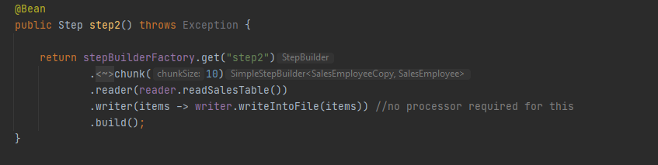

**Reader logic:**

@StepScope  
public ItemReader<SalesEmployeeCopy> readSalesTable() {  
 *log*.info("reading sales copy records from DB");  
 AtomicInteger i = new AtomicInteger(0);  
 List<SalesEmployeeCopy> salesEmployeeList = (List<SalesEmployeeCopy>) salesRepository.findAll();  
 *log*.info("sales objects from DB = " + salesEmployeeList.size());  
 return (() -> i.get() >= salesEmployeeList.size() ? null : salesEmployeeList.get(i.getAndIncrement()));  
}

**Writer logic:**

@StepScope  
public void writeIntoFile(List<? extends SalesEmployee> list) {  
 excelUtil.writeIntoExcelFile(fileLocation, list);  
}

This writeIntoExcelFile has logic to create a new excel file, create sheet, create row and then add header and salesperson objects into the excel file.

**properties:**

excel.file.location=F:\\Projects\\SpringBatch\\Employees.xlsx  
write.excel.file.path=F:\\Projects\\SpringBatch\\Employees-copy.xlsx  
com.example.demo.chunk.excel.file.path=F:\\Projects\\SpringBatch\\Employees-chunk-copy.xlsx